Observation:
Imported HR analytics dataset to excel and loaded it to power query by clicking on data tabget datafrom excel file.
In Employee master table: Kept first 800 Rows
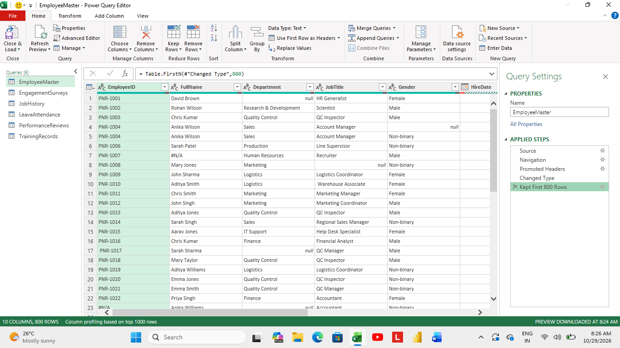
Removed duplicates values from employee id.
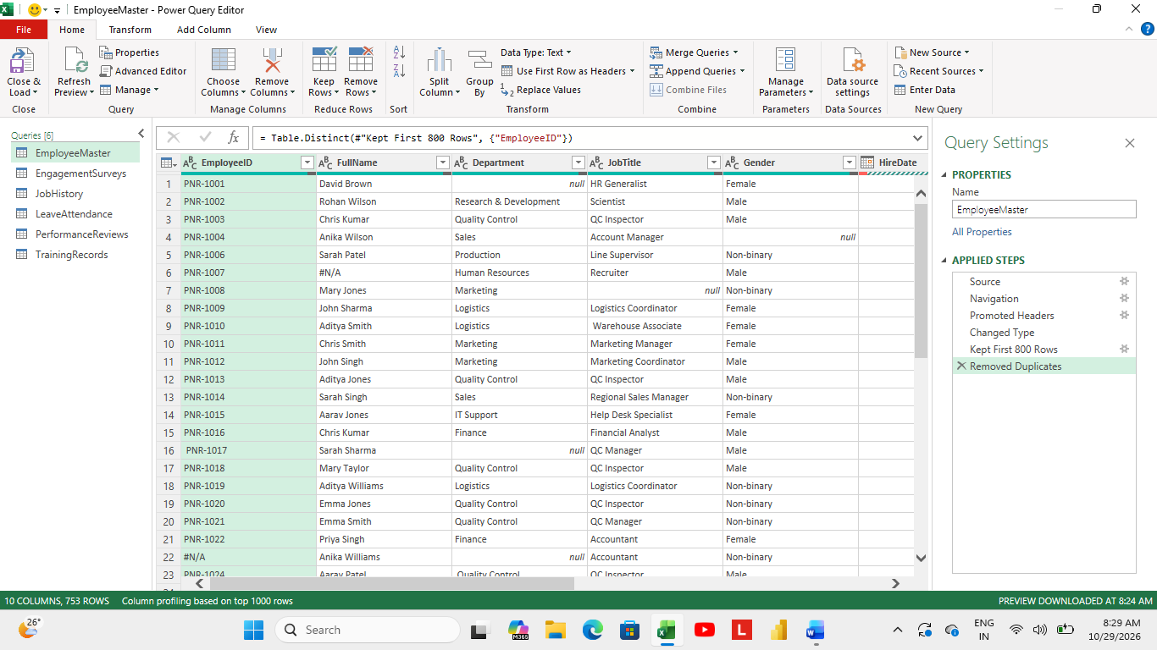
Replaced N/A and blanks as unknown employee in name column.
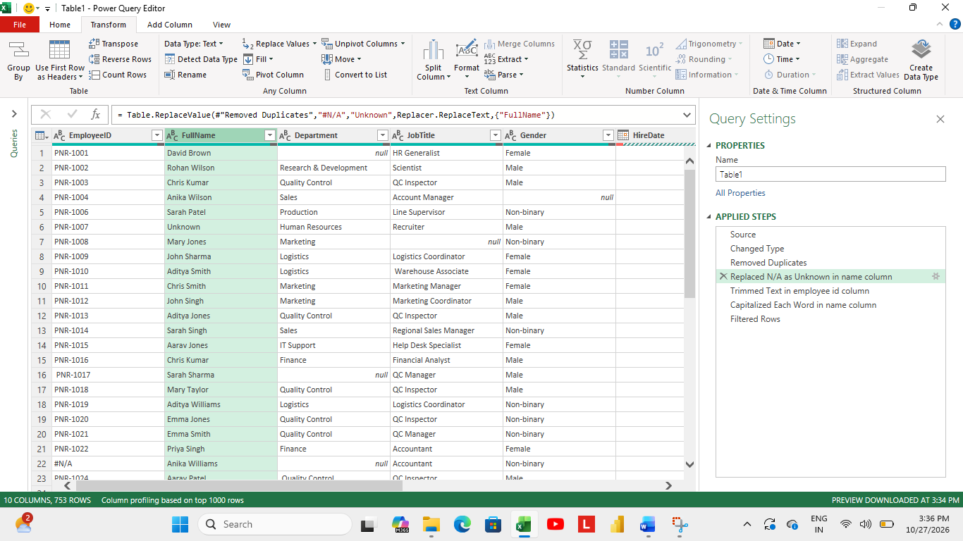

Used Trimmed function in employee id column to remove unwanted spaces.
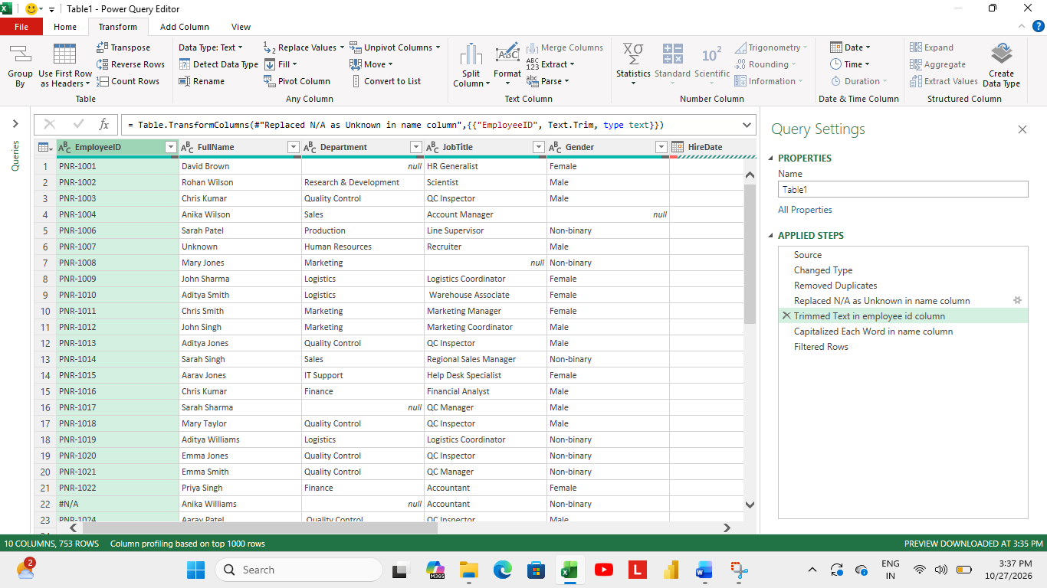

Used proper case function in name column.
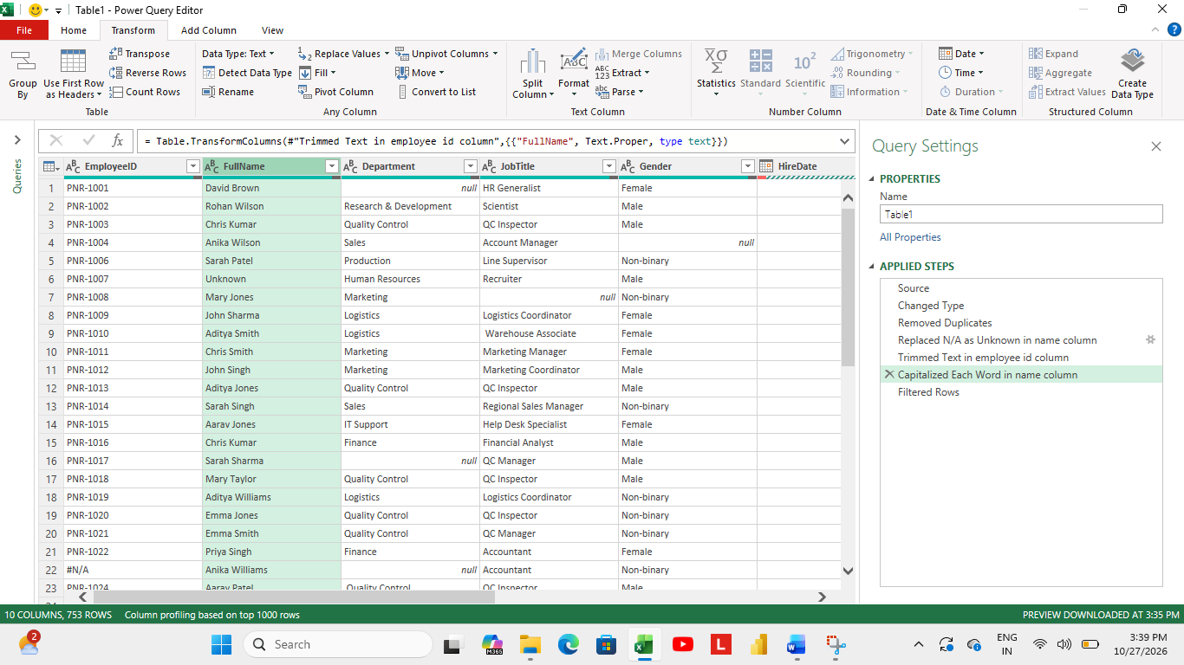

In HR analytics dataset it totally contains 5 tables, removed duplicates from all the tables, used trimmed function to all tables, and used capitalise each word where ever it is needed, as of how I did it in employee master table.
- After this loaded the all the data to excel. And started cleaning in excel itself.
- In employee master table after removing duplicates values in employee id column used sequence order for it like PN-1001, PN-1002, PN-1003…...so on.
- Missing values in department column is filled by keeping job tittle as base.
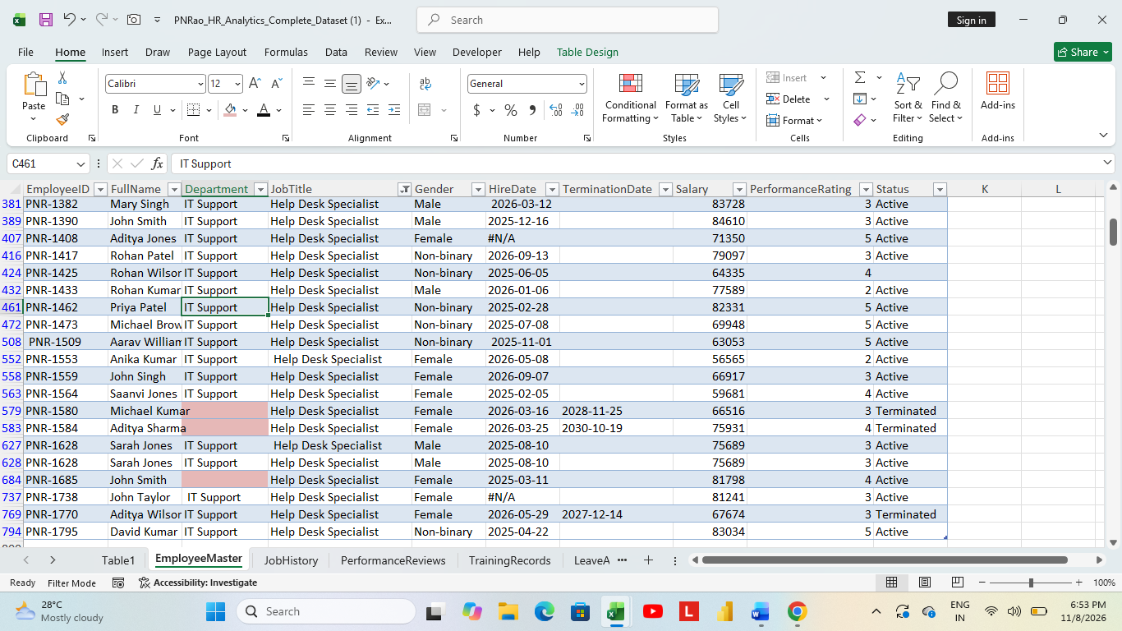
- Missing values in job tittle column is filled by keeping department as base and mode based.
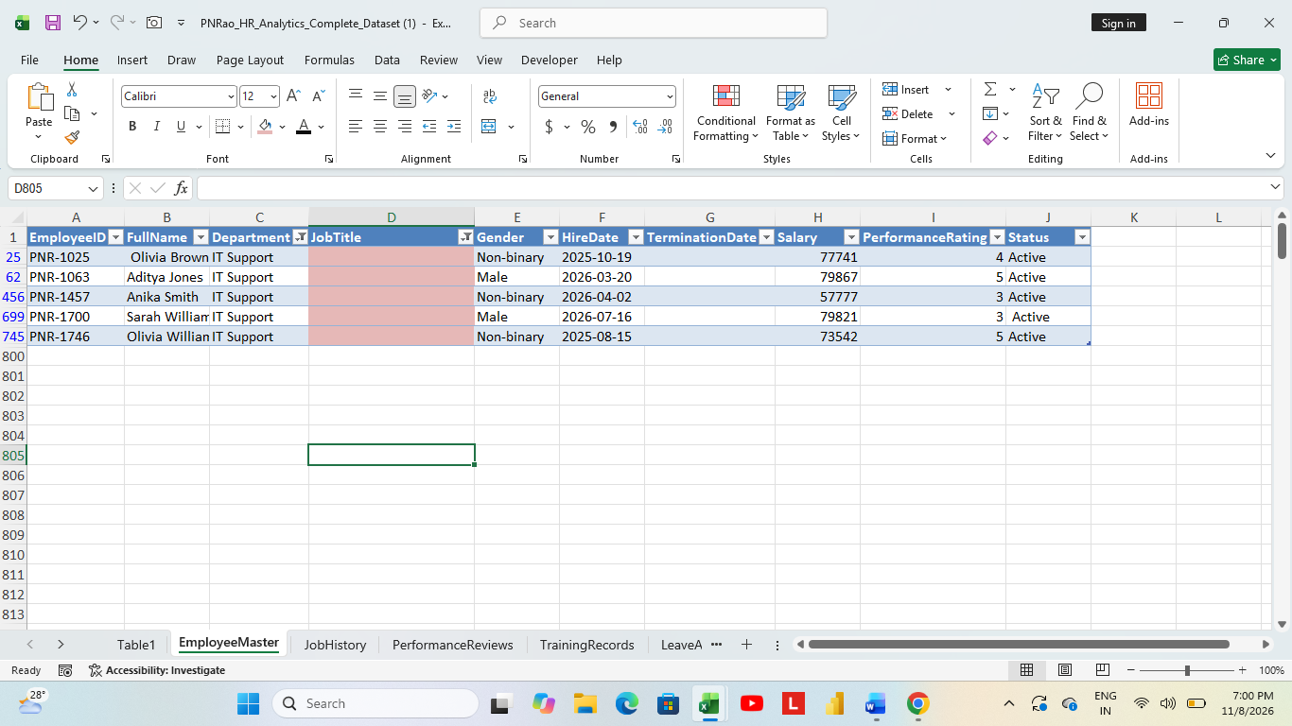

In IT Support department there are 3 sub job tittles based on mode which is highest count, it is filled in blanks rows.
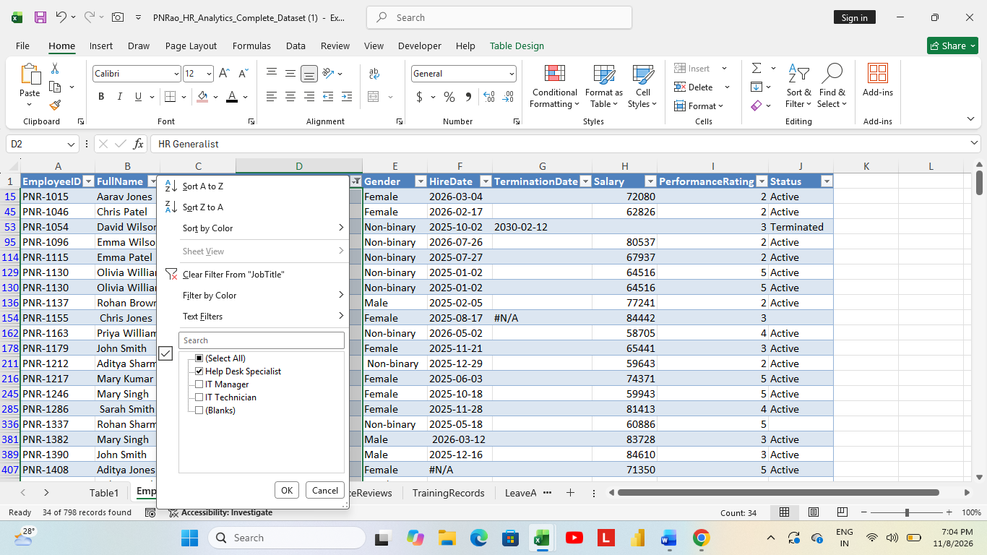
Here help desk specialist has highest count compare to others.
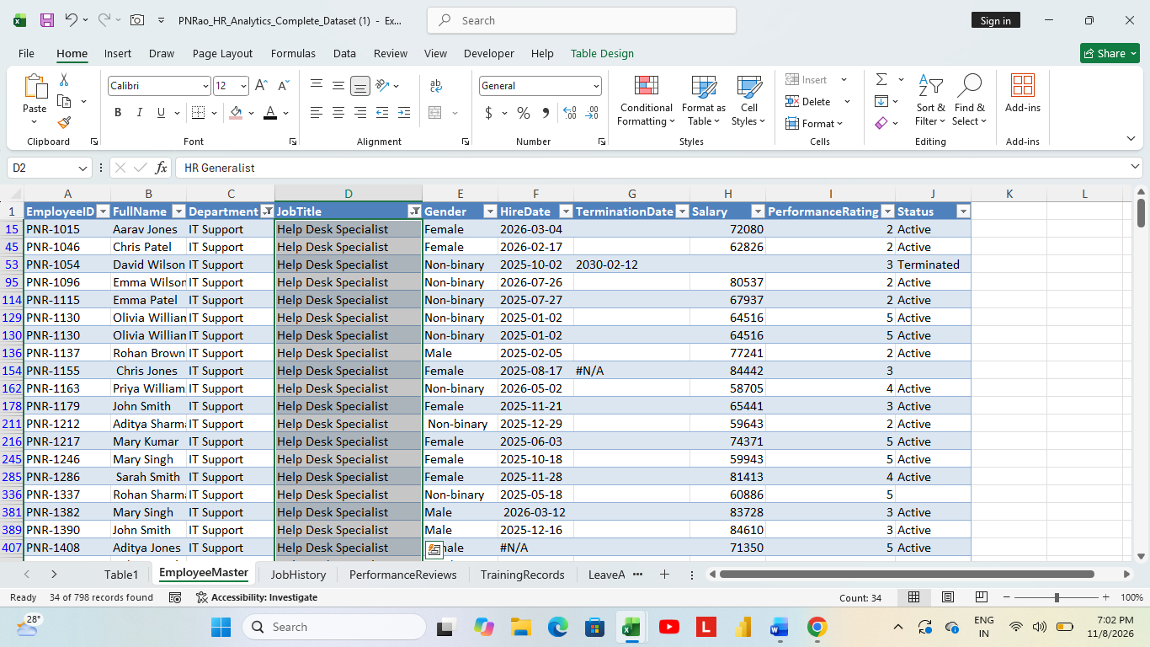

In Gender column I found blanks values, by filtering names column and in mode wise I decided what gender they actually belong to in some cases based on my opinion too I filled it.
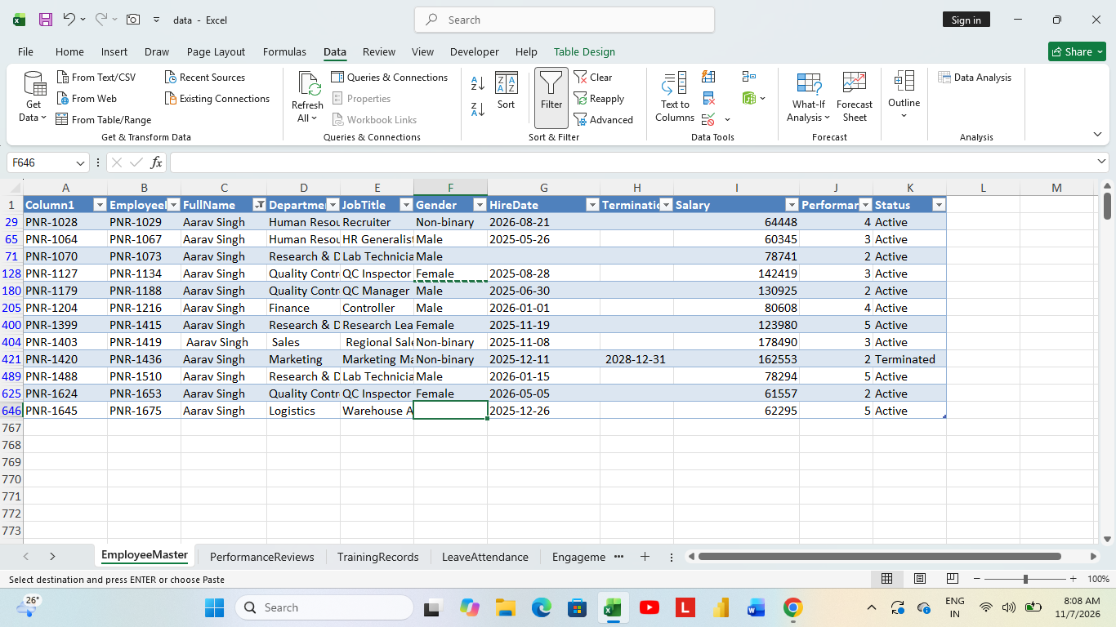
This is how I found average for salary column null values.
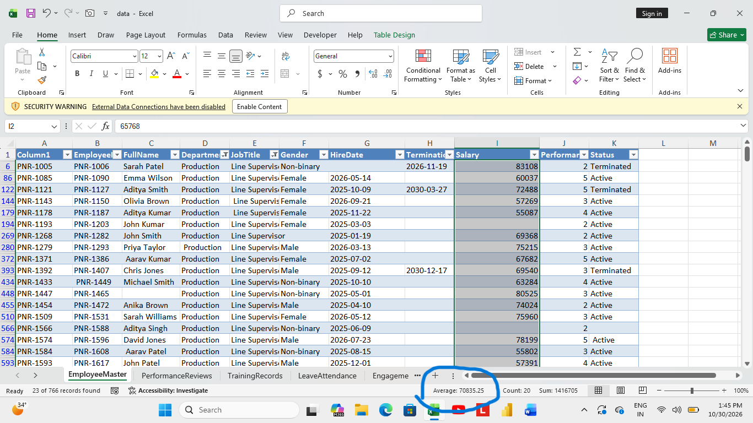
Manually entered active or terminated based on date, if termination date is mentioned that means the employee is terminated, if not the status is active.
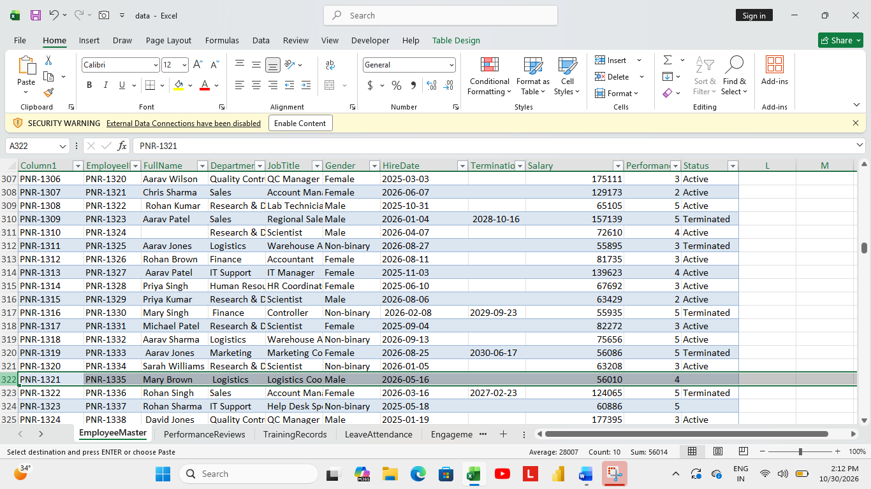

Performance score is also calculated as per average value by department and sub tittle(i.e.) job tittle.
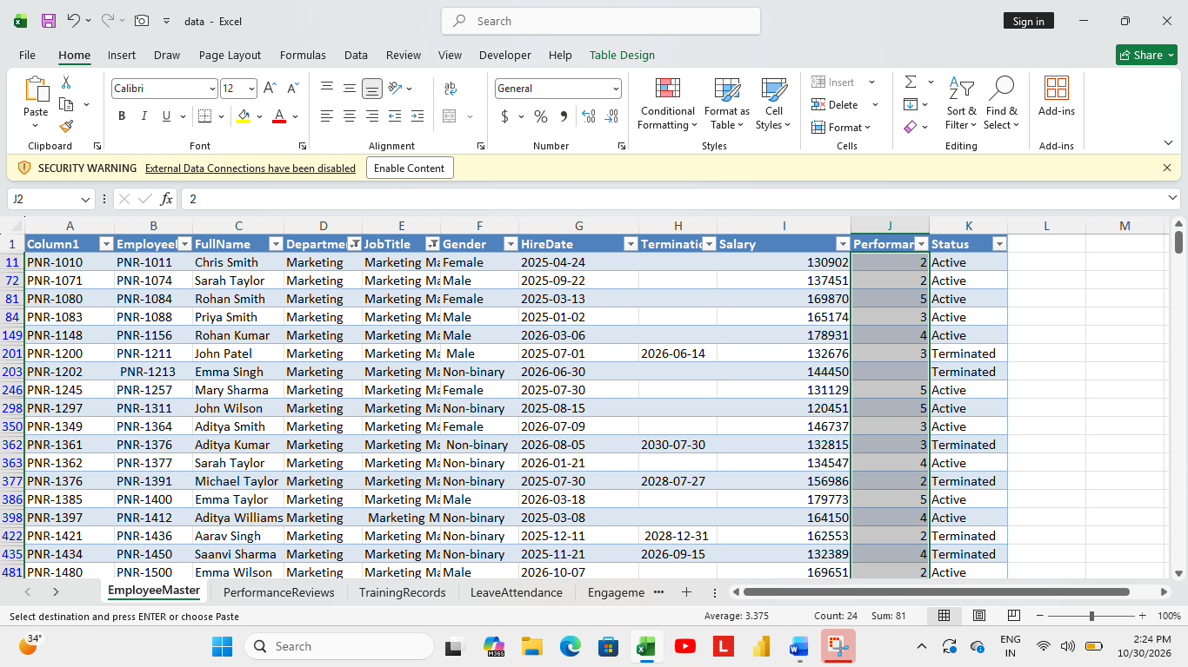

Performance review table:
- Used same employee id for performance reviews table from employee master table because that’s the corrected id after removing duplicates and used sequence order for it.
- Removed review date and reviewer id, in my option I think those are not useful.
- Using xlookup function added department column, to find missing values In overall score, problem solving, communication, teamwork, Department wise calculated average and filled it manually as said earlier.
Added department column to all tables using xlookup function, because based on it all missing values are found.

In training records table: Filled blanks cells in employee id column by order sequence, added department column based on it null values in course filled as per mode .
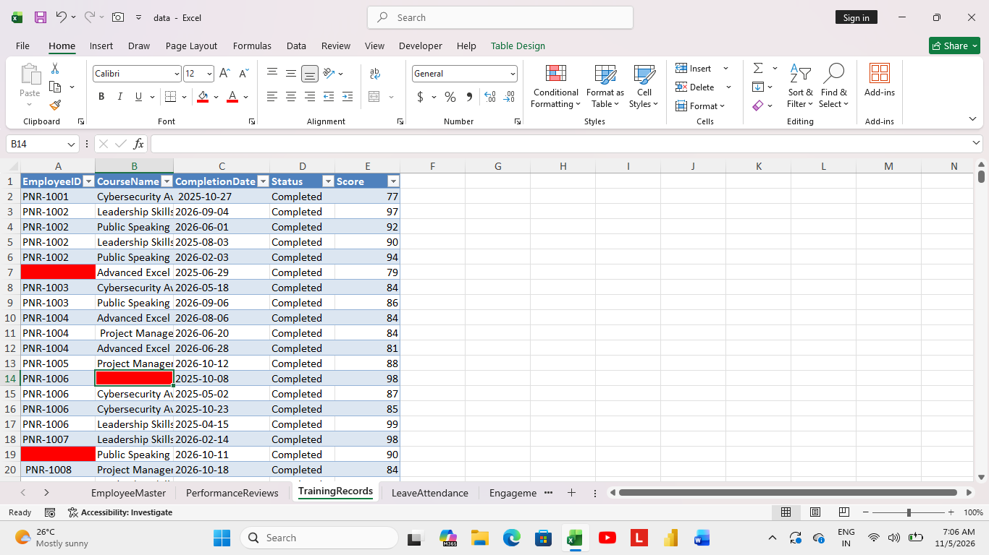

Leave attendance table: By analysing the data sequence, I decided it would be PNR-1136 in Employee ID and filled it manually.
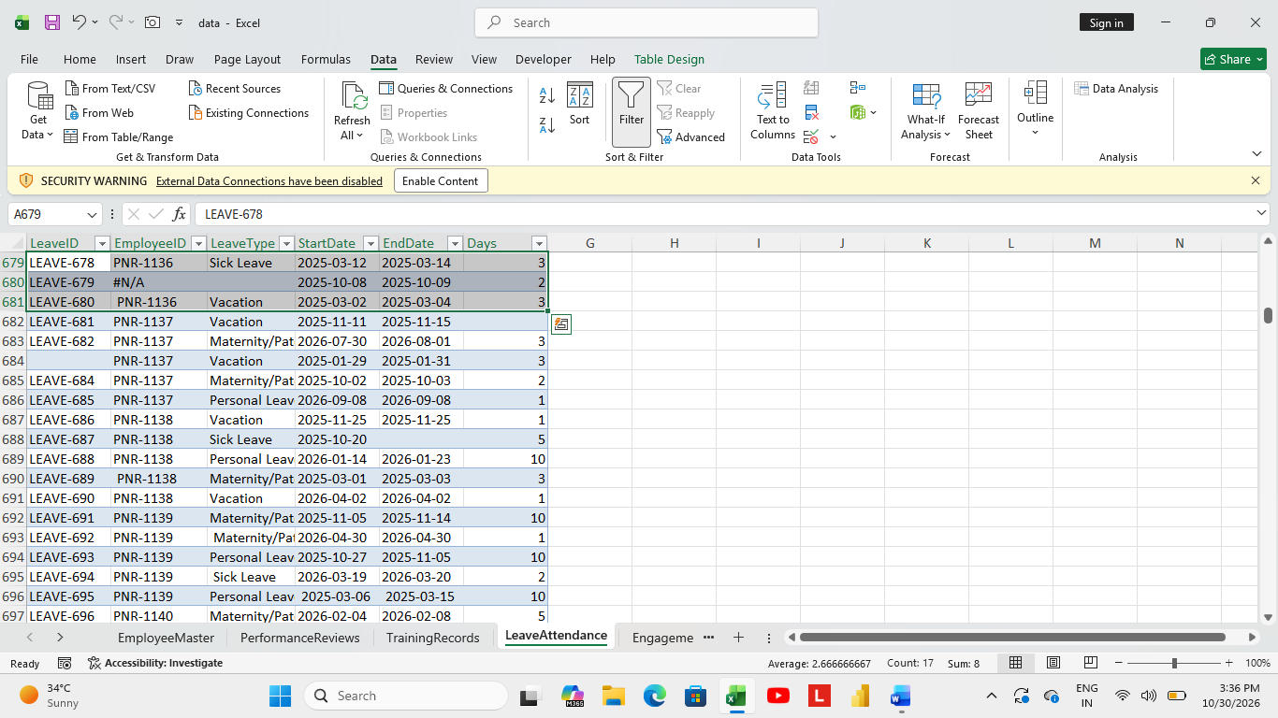
By the given dates, I counted it to fill missing values in days column.
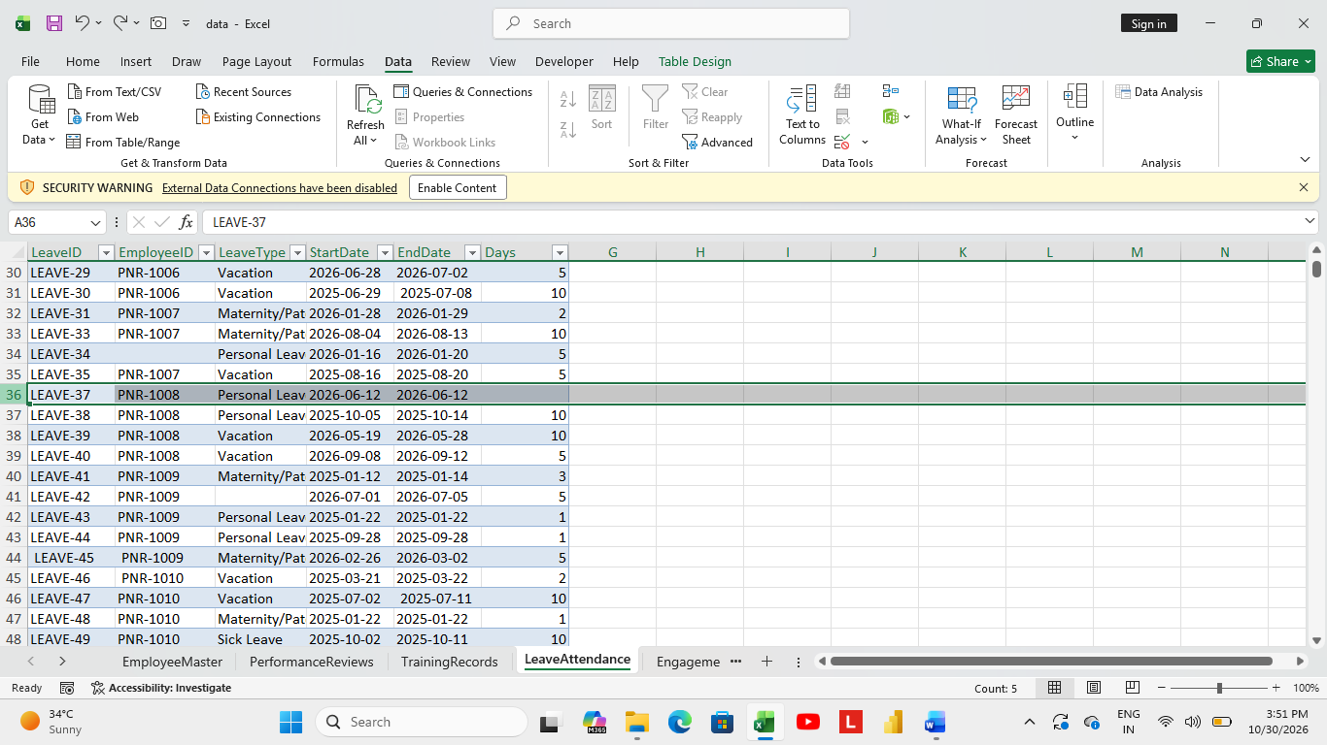

Missing dates been calculated by end date (end date – days i.e., 2025-03-25 – 3, u get 2025-03-23).
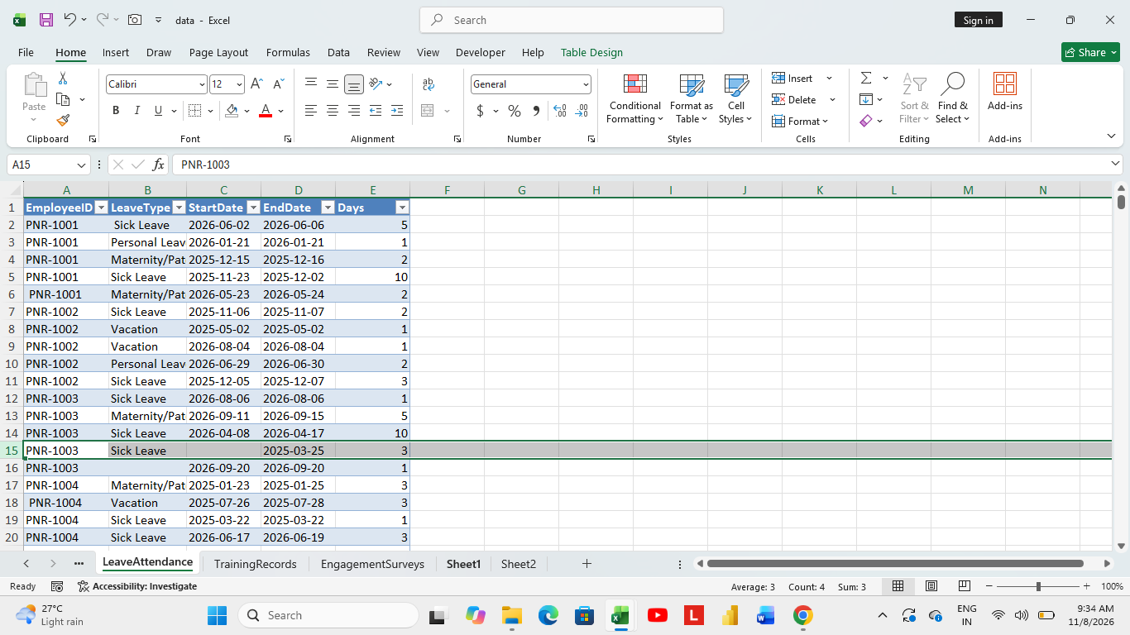

Used Xlookup function to extract department column from employee master table, to find mode wise leave type and filled it manually.
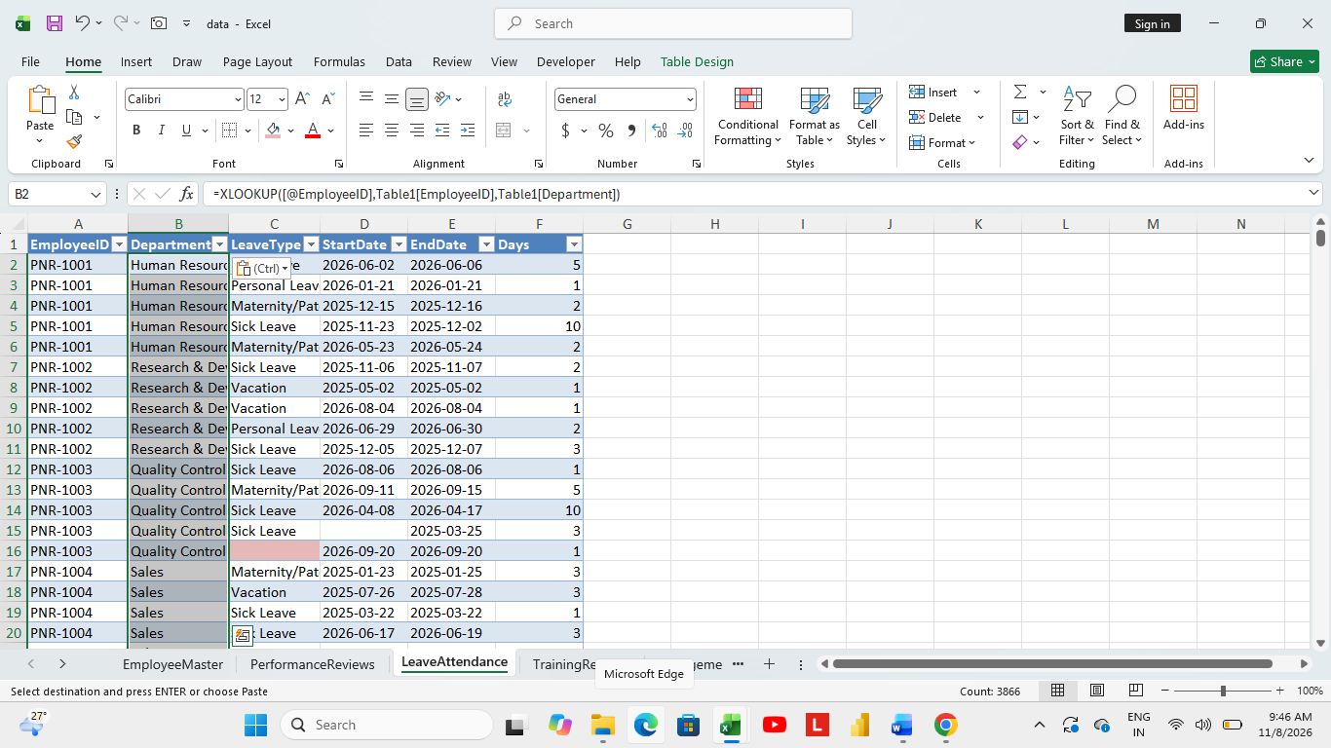

In Engagement table: Based on the sequence, filled it, added department column as said before, based on it filled missing values in overall satisfaction score, work life balance score, feedback score as per average as done before for all other tables.


